Security Incident Report
Incident Overview
- Incident ID: 8814]
- Date/Time Detected Jun 4th 2026 at 05:09
- Reported By: [TryHackMe]
- Incident Type: [Suspicious Url in email]
- Severity: Medium
- Status: [Closed]

Executive Summary
On Jun 4th 2026 at 05:09, mail contains one or more external links due to potentially suspicious characteristics.
Initial analysis suggests Fishing email sent to r cipient j.garcia@thetrydaily.thm from sender onboarding@hrconnex.thm containing the following link (https://hrconnex.thm/onboarding/15400654060/j.garcia)
Incident Details
- Affected Systems: [User email]
- Affected Users: j.garcia@thetrydaily.thm
- Detection Method:[SIEM
- Environment: Email

Investigation Summary
Analysis of the incident revealed:
- Key Behavior Observed:
  - Email received by user j.garcia@thetrydaily.thm with suspicious link inside
Process Activity (if applicable):
[Process chain]
- Network Activity (if applicable):
  - Outbound: N/A
  - Inbound: N/A
- Artifacts Identified:
  - Files: N/A
  - Hashes: N/A
  - URLs/Domains: https://hrconnex.thm/onboarding/15400654060/j.garcia
Threat intelligence sources classify the activity as Suspicious

Timeline of Events
Time | Event
[:Jun 4th 2026 at 05:09] | Detection
[N/A] | User/system interaction
[N/A] | Malicious activity observed
[Jun 4th 2026 at 6:00] | Investigation started
[Determined alert was False Positive] | Containment
[:Jun 4th 2026 at 6:20] | Resolution

Impact Assessment
- Systems Impacted: [None]
- Users Impacted: [1]
- Business Impact: [None]
- Data Exposure: [No]
- Persistence: [No]
- Lateral Movement: [No]

Response Actions
- Took Ownership of the Alert on Jun 4th 2026 at 06:00
- Investigate Logs running KQL queries on Company email logs to determine scope on suspicious activity
- Found email with URL link inside
- Ran URL Scan on suspicious link
- Determine that link was not malicious
- Ran KQL query to determine if user evr clicked on the link
- Determine referring to the logs that user did not click on the link
- Marked Alert as False Positive
- Reported Investigations
- Tune in alerts to reduce the number of False Positives on SIEM systems and reduce Alert Fatigue.

Root Cause
Primary Cause:
[Alert Misconfiguration Configuration]
Contributing Factors:
- email was legit and expected
- [URL link was not malicios ]

Recommendations

Indicators of Compromise (IOCs)
- IPs: [List]
- Domains: [List]
- Hashes: [List]
- Files: [List]

Appendix
- Logs reviewed: [Data Table: tbl060474321_CL]
- Tools used: [SIEM]
- Evidence: [Screenshots, exports]
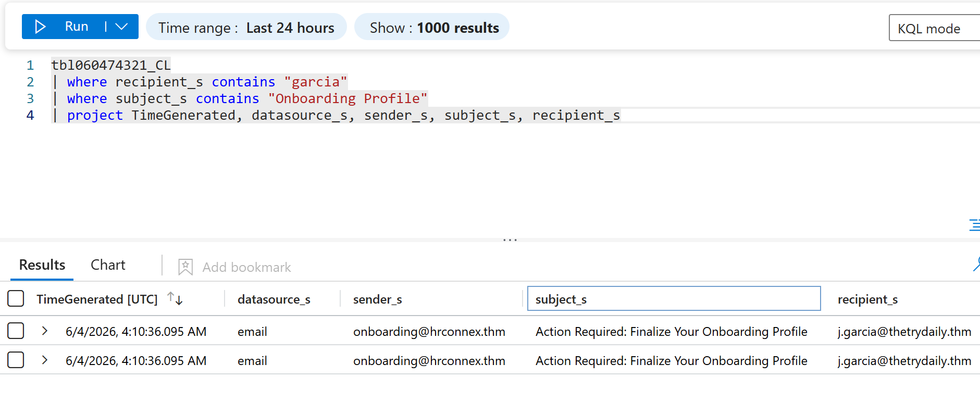
KQL Query Showing email logs of email being received by Recipient user
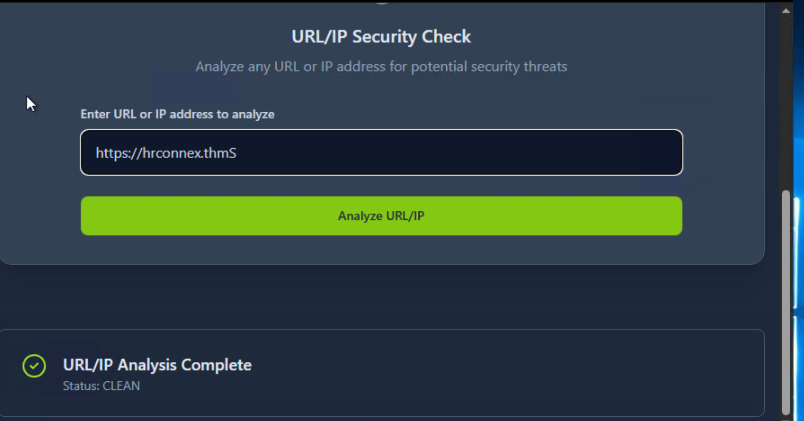
URL scan on “Suspicious” link found inside email (results show Link is not Malicous)

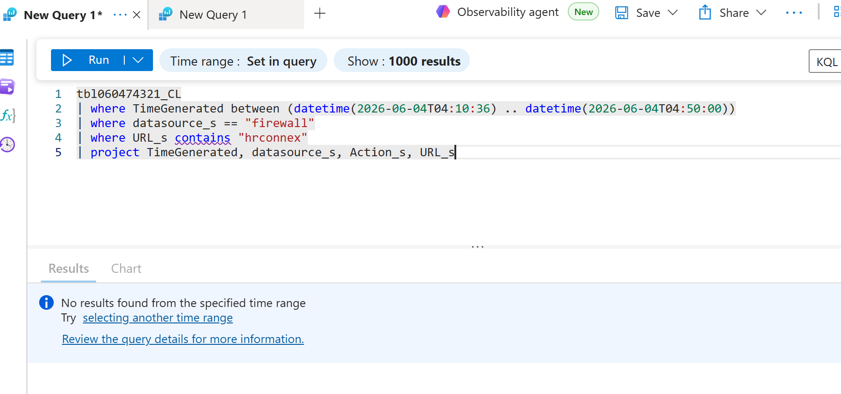
KQL Query showing used did not Clicked on the link.

2. MITRE ATT&CK–MAPPED VERSION (Add-On Section)
Add this section to any report when needed.
this for quick notes, Slack updates, or ticketing systems.

SOC Incident Summary (Short Form)
- Time Detected: [6/4/2026, 4:10:36.095 AM]
- Alert Source: [SIEM]
- Type: [Suspicios Email Detected]
- Severity: [Medium]

Scope:
- Hosts: N/A
- Users: 1
Key Findings:
- Email received by User j.garcia
- Email link not malicious
Actions Taken:
- Review logs and check if link was clicked on
- Scanned Link to discover url was not malicious

Status: [Resolved]

